Optical Absorption Spectroscopy

Note: The paragraphs in blue are information taken from books. Those in black are what have been said in class.
- Sun, S.F. Physical Chemistry of Macromolecules. Wiley-Interscience, Hoboken: 2004.
- Lightner, D.A & Gurst, J.E. Stereochemistry from Circular Dichroism Spectroscopy. Wiley-VCH, New York: 2000.
- Nakanishi, K., Berova, N. & Woody, R.W. Circular Dichroism. VCH, New York: 1994.

Some Definitions
Linear Dichroism (LD): Differential absorption between two orthogonal components of linear polarized light. This phenomenon occurs naturally in stretched polymers.

Circular Dichroism (CD): Differential absorption between left and right circular polarized light components. This phenomenon occurs naturally in chiral compounds. (Δε = ε_{L} – ε_{R,} where ε is the molar absorptivity and L and R are left and right respectively)

To Refresh the Memory…
All the atoms, except for the hydrogen, of the nucleic bases have 2p orbitals, which can each contain up to 2 π electrons of opposite spin (½ and -½). The number of π molecular orbitals for each base will be equal to the number of 2p orbitals making up the system (e.g.: 8 for C, U, and T; 10 for A; 11 for G). Only the lowest-energy π orbitals will be filled with electrons (e.g.: 5 for C, U, and T; 7 for G). As a result, a large number of π → π* transitions from the low-energy filled π orbitals to the higher-energy unfilled orbitals are possible. These π → π* type of transitions have high intensity. The non-bonding electrons can give rise to n → π* transitions of low intensity that are buried under the π → π* transitions.

Optical Activity of Nucleic Acids
The nucleic acid bases alone have a plane of symmetry; therefore, they are not intrinsically optically active. The sugars (ribose and deoxyribose) are asymmetric. Because a base is attached to the 1’ carbon of a sugar, the latter can induce a circular dichroism in the absorption bands of the chromophoric bases due to the asymmetry that the sugar adds to the base. The bands are more intense if they are π → π* transitions and weaker if they are n → π* transitions. However, the intensity of the CD is low because it is just an effect of the asymmetric sugar inducing a CD in the chromophoric (but symmetric) base. This last statement is true for monomers.
On the other hand, for the nucleic acids, the hydrophobic planes, the hydrophilic edges (-NH₂, =O groups of the bases), and the charge-charge interactions, cause the bases to stack and the polymers to assume a helical structure. As a result, a preferential handedness is induced in the helix by the asymmetric sugars, giving the polymer as a whole a (super) asymmetry. The electric transitions of the bases are now in close proximity, and can interact to yield a CD of high intensity. Complementary polynucleotides can form double-stranded helical structures where they also the base-base interactions that give intense CD spectra.

(Feb17th, p.1 from BUGS website. Shown on the following page, unlabelled figure)
Adenine does not have optical activity because it is a planar molecule. However, adenosine has optical activity because its sugar group adds asymmetry to the adenine molecule. Its absorption (or CD) is maximal at 260 nm and is negative (curve c). The curves are plotted as Δε versus the wavelength, where Δε is the difference in absorption between left-handed and right-handed circular polarized radiation. The values of Δε are rather small for nucleic acid bases, in the orders of 10⁻⁴ (less than 0.1% of difference at 260 nm). However, there is enough optical activity to be detected/seen, just by virtue of the influence of the sugar.
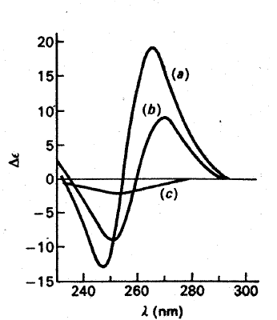
For the dimer, there is clearly more than one absorption because two bands are seen, one negative and one positive (curve b). As for the poly-A, the phenomenon is even more distinctive because the curve is more asymmetrical (curve c). However, even though there are two peaks, it does not mean that the positive peak represents one absorption band and the negative peak represents the other absorption band. Because if one looks at the UV absorption spectrum for adenine and compares it with poly-A, one will see little difference. One does see DNA hyperchromism (Increase in absorption intensity).
If there is an exciton splitting as a result of an interaction between two bases, then a shift would be expected. In DNA interactions, the shift is expected to be small because the transition dipole moments that give rise to the extinction coefficient are not that large. Even if two bases are stacked together the shift will still be small in comparison to the interaction of two peptides units, which gives a significant shift.
For example if the absorption spectrum of poly-A looks like Figure 1 (red band, on the right), then it would be very hard to tell the difference from the absorption spectrum of adenine, which looks like Figure 2 (the black/left band, in Figure 1).

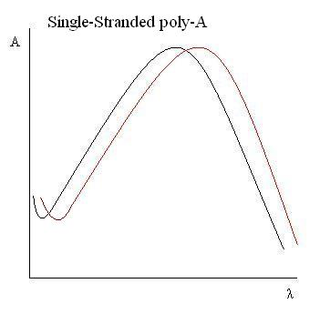 | 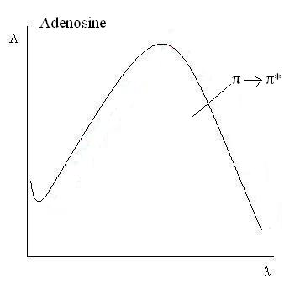
Figure 1. UV Absorption Spectrum of Poly-A (red) and Adenosine (black) | Figure 2. UV Absorption Spectrum of Adenine

However, if one is looking for a difference between the two molecules when the splitting is small due to the excitonic interactions, the splitting can be magnified if the interaction is sufficiently asymmetric, so that the two exciton states that result have opposite signs in circular dichroism.
In the point of view of circular dichroism, if the components can be individually looked at, poly-A has red-shifted (Figure 1), resulting in a positive band (positive contribution) and the monomer has blue-shifted, resulting in a negative band (Figure 3).

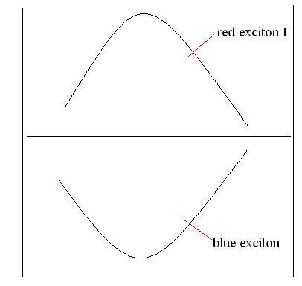
However, this is not what one sees due to the fact that one looks at the difference between the left-handed and right-handed circular polarization (Δε = ε_{L} – ε_{R}) as a function of the wavelength. As a result, what is really seen in circular dichroism is shown in Figure 4.

Figure 3. Bands of Individual Components

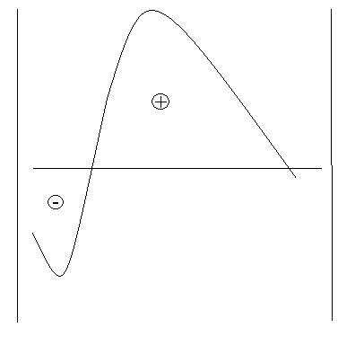
From the positive peak, there is also no negative contribution. However, as one steps back to small wavelengths, there is negative contribution, but since the positive contribution (red exciton) is still more significant, the band is still on the positive side. After the isobestic point, the peak is negative because there is more negative contribution (blue exciton).
When the dichrograph is decomposed, it really looks like two similar peaks with a small shift between the two (Figure 1).

Figure 4. Dichrograph (y-axis = Δε = ε_{L} – ε_{R,} x-axis = λ)

Circular Dichroism or Optical Activity: Contributions in proteins

- Asymmetric Center in the Molecule: All the individual amino acids have CD spectra except for glycine.
- Exciton splitting: There are chromophores that do not necessarily have an asymmetric center themselves but interact in an asymmetric manner, resulting in exciton splitting.
- Chromophores in asymmetric environment: Induced circular dichroism by the environment in which the protein is exposed to. The contributions from the environment depend on the conformation state of the protein.

The Origin of Circular Dichroism
For absorbance to occur, the transition dipole moment should not be equal to zero. The larger the change in the dipole moment is, the larger the absorbance. In UV absorption, only the translation of electric charges during the short time of excitation is important. However, a molecule can display strong absorbance even if it does not have display any CD. Such is the case for adenine. Circular dichroism is obtained when the dot product of the electric transition dipole and magnetic transition dipole is not equal to zero (μ_{el} • μ_{m} ≠ 0).
If an electron of a molecule is excited along its transition dipole moment direction and if its changing magnetic moment is perpendicular to it, then there is no optical activity.

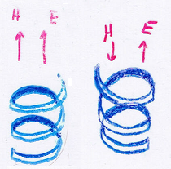
(Feb17th, p.2 from BUGS website – unlabelled figure right there→)
If a magnetic moment is induced by accelerating an electron in a wire (such as an antennae), if the electron is oscillating, then an oscillating electric field will be induced, which in turn will induce an electric field. Using the right hand rule, the magnetic moment will be perpendicular to the electric field. As a result, there will be no optical activity.
If an electron is excited in a coil, and if you follow the electron using the right hand rule and if the coil is right-handed, then the generated magnetic moment will not be perpendicular to the changing electric field, but as a component in the same direction as the electric field.
If the electron is excited in the same direction as in the previous situation, but in a left-handed coil, using the right-hand rule, the magnetic moment will be in a direction opposite to the electric field.

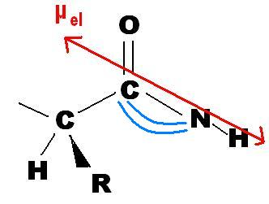
If a molecule is sufficiently asymmetric and has a helical twist in it, the π electrons that are excited by the electric field vector not only follow the electron cloud, but because the center is asymmetric, with a R group coming out of the paper and one going in on the neighboring carbon (Figure 5), a spiraling electron cloud is obtained. If the R-group out-of-plane is electronegative, so that the electrons are pulled out of the paper, then the twist is trans. If the electrons are pulled in from the R-group going in, then the twist is cis.
Figure 5

When the electrons are accelerated due to the excited pack of π electrons by the electric field vector, because of the helical twist, the induced magnetic moment is not perpendicular to the electric field vector.

Generation of Circular Polarized Light
In two racemic mixtures, where for one, the helix tends to twist in one way and for the other, it tends to twist in the other way, then one will preferentially absorb right-handed circular polarized radiations and the other will preferentially absorb left-handed circular polarized radiations. Why is that?
Linearly polarized light is generated by passing natural light through a prism or dichroic polarizer and it is polarized in all the possible desired directions. For linear dichroism, natural light is polarized in the horizontal direction.
Circular polarized light is generated by passing linearly polarized light through a birefringent crystal (or birefringent plate, which is typically a very thin quartz plate cut parallel to its optical axis) and polarizing it at 45º (with respect to the plane of incident light). This linearly polarized light is broken down in two: electric field component in the y-direction and in the x-direction (The z-axis is the direction of the propagation of the radiation). When the components come out of the sample, they recombine and you get polarization radiation still at 45º.
In circularly polarized light, the electric field vector, which is always perpendicular to the direction of propagation of the radiation (along the z-axis), revolves around the propagation axis, either clockwise (R) or counterclockwise (L) once every wavelength λ. The left-circularly polarized light vector traces out a left-handed helix whereas the right-circularly polarized light vector traces out a right-handed helix.
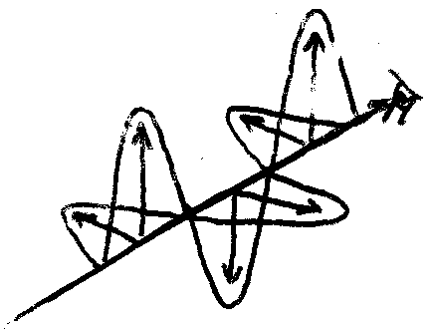
However, if in the system, the refractive index in the y-direction is not equal to the refraction in the x-direction, then inside the birefringent (dichroic) crystal, the x- and y-direction of the electric field component are not in phase anymore. The frequency stays the same, but the radiation moves more slowly for one direction than for the other. As a result, this shows up as a shift in the wavelength (or retardation in the wavelength). When the radiations emerge from the sample, because they are out of phase, they are no longer able to recombine to give polarization at 45º. Instead, they give radiations that are elliptically polarized.

(Feb17th, p.5 from BUGS website – again, unlabelled and right)
In the figure, from the point of view of the eye, following the electric field component starting from the vertical direction, the light is in a clockwise direction.
If one of the directions of the electric field component is retarded by exactly 45º (π/4) with respect to each other, then at one point in time, you will only see the vector in y-direction, at another time, only on the zero, at another, only in the x-direction. At other times, it is a combination of both. As a result, circularly polarized light is obtained, not elliptically polarized light. This retardation can be generated using a quarter-wave plate.
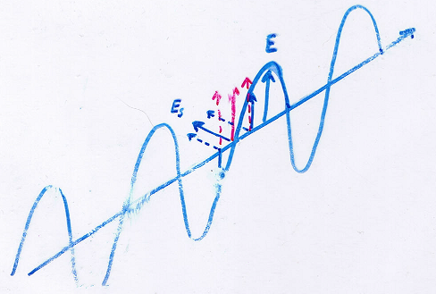
(Feb17th, p.3 from BUGS website – to the right)
If circular polarized light is passed through a sample, it will preferentially interact with one of the two components, the one that has the matching changing electric and magnetic dipole moments.
In the bottom of the figure, there are two electric components (blue) and one magnetic component (red). The electric component that is parallel to the magnetic moment and the magnetic moment are acting together. If there is a shift, then the other electric component will act together with the magnetic moment, resulting in a change of direction. This is illustrated on the top of the figure. Depending on the direction of the solenoid, one electric component is absorbed better as opposed the other, where the result is displayed on CD spectra.
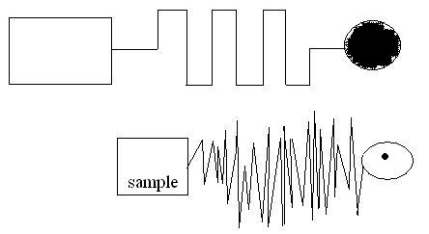
Because the CD observed is usually very small, there are various ways to detect the signal. An alternate technique is to use a crystal that is not birefringent until a high voltage is applied across it. If you oscillate the voltage in another direction, you flip the birefringence from larger in y and smaller in x to smaller in y and larger in x, so the light that passes through the sample flips from right-handed to left-handed circularly polarized.
Figure 6 For example, at the bottom of the Figure 6, there is circularly polarized light passing through the sample, but the detected signal is very small and is buried in the noise. However, if the voltage is changed accordingly (same frequency, in-phase), a much more significant signal is detected (top of Figure 6).

Application of CD
A few years ago, some people have been able to transmute a α-helical protein to a β-sheet protein or vice-versa making changes in less than 40% of the amino acid sequence. The protein was a domain of immunoglobulin, which has a lot of β-sheets. They tried to change it in to a α-helical protein. They monitored the transition with fluorescence, NMR, site-directed mutagenesis, and CD. The original protein had CD, which looks like on Feb17th, p.8 from BUGS website. After the transition, the new protein had a CD, which looks like a typical α-helical protein Feb17th, p.10 from BUGS website (the figures are shown below).




